**PROJECT REPORT** ON

# Blood donation system

# We care

**BACHELOR OF ENGINEERING**

**IN**

**COMPUTER SCIENCE & ENGINEERING**



## Submitted to: Er GAGANDEEP KAUR

**Submitted By:**

* **BHUVANYU OLIYAN:(20BCS9245)**
* **SHRUTI SHREYA:(20BCS9229)**
* **SAURABH PANDEY-(20BCS9269)**
* **ALOK KUMAR JHA-(20BCS9261)**

**DEPARTMENT OF COMPUTER SCIENCE & ENGINEERING**

**Chandigarh University, Gharuan**

# Table of Contents

**Topic Page No.**

Certificate 3

Students ’s Declaration 4

Acknowledgement 5

List of Figures 6

Definitions, Acronyms and Abbreviations 7

Abstract 8

## CHAPTER 1 INTRODUCTION 9-12

**1.1** Theoretical explanation 9-10

**1.2** Software and Hardware tools required for project 11-12

## CHAPTER 2 ARCHITECTURE DIAGRAM 13-16

**2.1** Use case diagram 13-14

**2.2** Sequence diagram 15-16

## CHAPTER 3 17-18

**3.1** SRS 17-18

## CHAPTER 4 19-23

**4.1** ER diagram 19-20

**4.2** DFD diagram 21-23

## CHAPTER 5 MATERIAL AND METHODOLOGY 24-26

**5.1** Proposed work 24-25

**5.2** Team work 26

## CHAPTER 6 RESULTS AND SNAPSHOTS 27-33

**6.1** Result 27

**6.2** Snapshot 28-33

## CHAPTER 7 CONCLUSION AND FUTURE SCOPE 34-35

**7.1** Future Scope 34

**7.2** Conclusion 35

**REFERENCES** 36

## CERTIFICATE

This is to certify that the work embodied in this Project Report entitled **“BLOOD DONATION SYSTEM”**, being submitted by

1.BHUVANYU OLIYAN-(20BCS9245)

2. SHRUTISHREYA-(20BCS9229)

3..SAURABH PANDEY-(20BCS9269)

4.ALOK KUMAR JHA-(20BCS9261)

OF 3RD Semester for partial fulfilment of the requirement for the degree of.

**( “ Bachelor of degree in** **Computer Science & Engineering** **”**)

in **“Chandigarh University”** during the SUMMER BREAK 2021 is a record bona fide piece of work, carried out by student under my supervision and guidance in the **“ Department of Computer Science & Engineering ”,** of **Chandigarh University.**

##### TEAM WORK –

* **FRONTEND – SAURABH PANDEY, SHRUTI SHREYA**
* **BACKEND –**BHUVANYU OLIYAN, ALOK KUMAR JHA

## DECLARATION

We, student of Bachelor of Engineering in Computer Science & Engineering , 3RD  Semester , session: 2021, Chandigarh University, hereby declare that the work presented in this

Project Report entitled “BLOOD DONATION SYSTEM”, ” is the outcome of our own work, is bona fide and correct to the best of our knowledge and this work has been carried out taking care of Engineering Ethics. The work presented does not infringe any patent work and has not been submitted to any other university or anywhere else for the award of any degree .

**Students details and Signature**

BHUVANYU OLIYAN- (3RD SEMESTER STUDENT)

SHRUTI SHREYA- (3RD SEMESTER STUDENT)

SAURABH PANDEY(3RD SEMESTER STUDENT)

ALOK KUMAR JHA(3RD SEMESTER STUDENT)

**APPROVED & GUIDED BY:**

**To our Project In charge “ER GAGANDEEP KAUR”.**

**THIS PROJECT WAS MADE UNDER THE GUIDANCE OF OUR MENTORS ANKITA SHARMA AND SAUMYA MAM**.

## ACKNOWLEDGEMENT

We would like to express our deep and sincere gratitude to our Project In charge **ER GAGANDEEP KAUR** for giving us the opportunity to do the project and providing valuable guidance throughout this research. Their dynamism, vision and exquisite efforts have deeply inspired us. They taught us the methodology to carry out the research and to present the research work as clearly as possible. It was a great privilege for us to study and work under their guidance.

We owe the completion of my project to our project Mentor for her continuous support and guidance.

**LIST OF FIGURES**

|  |  |  |
| --- | --- | --- |
| S NO. | FIGURE NAME | PAGE NO. |
| 1. | USE CASE DIAGRAM | 14-15 |
| 2. | SEQUENCE DIAGRAM | 16-17 |
| 3. | ENTITY RELATIONSHIP DIAGRAM | 21-22 |
| 4. | DFD | 24 |
| 6. | ZERO,ONE LEVEL DFD | 25 |

## DEFINITIONS, ACRONYMS AND ABBREVIATIONS

* **DFD( DATA FLOW DIAGRAM**)-A data-flow diagram is a way of representing a flow of a data of a process or a system. The DFD also provides information about the outputs and inputs of each entity and the process itself. A data-flow diagram has no control flow, there are no decision rules and no loops.

* **ER DIAGRAM (ENTITY RELATIONSHIP DIAGRAM)-**An entity–relationship model describes interrelated things of interest in a specific domain of knowledge. A basic ER model is composed of entity types and specifies relationships that can exist between entities.

* **UML DIAGRAM(UNIFIED MODELLING LANGUAGE)-**A UML diagram is a diagram based on the UML(Unified Modeling Language) with the purpose of visually representing a system along with its main actors, roles, actions, artifacts or classes, in order to better understand, alter, maintain, or document information about the system**.**

## ABSTRACT

Our Aim is to design and create a data management System for and a fully functioning website “ BLOOD DONATION SYSTEM” Blood Donation Management System is a management system website that enables individuals who want to donate blood to help the needy.

The main objectives for developing the website is to educate the community on the benefits of blood donation, develop a Web-Based Blood Bank System to manage the records of donors and recipients, and encourage voluntary blood donation, easily accessing any information about blood type and the distribution of the blood in various hospitals This website has a very user friendly interface. Thus the users will feel very easy to use. By using this portal viewer can see the data of required blood group of their city of different hospitals,

after he /she share his/her information .Thus all the information of viewer in stored in database connected to the website and is completely secured the information is not disclosed to any other third party sources and existing information can be edited or deleted too by the Administrator. The viewer can also use the website to see WHO statistics and facts from our “WE CARE” website.

**CHAPTER 1**

## INTRODUCTION

This project is designed for social cause to help people in their hard time. These website is created to be used by any NGO or by Government .The project Blood Donation Management System is a project that is designed For the blood bank to gather blood from various sources and distribute it to The needy people who have high requirements for it.The software is designed to handle the daily transactions of the blood bank And search the details when required. It also helps to register the details of donors.

We have also given our contact details in case of any discrepancy user can directly contact us through contact no. , email or any other social networking site given in link in project.

### Benefits of OUR COVID WEBSITE

* Can be used from anywhere in the world.
* . Can be accessed anytime.
* Quick Search
* Customize to Volunteer.
* Better Communication
* Time Optimization.
* Cost Optimization
* Better Communication.

## 1.2 Software and Hardware tools required for Project-

### SOFTWARE

### • HTML

HTML stands for Hyper Text Markup Language**.** Itis the standard markup language for creating Web pages**.** It describes the structure of a Web page**.**It consists of a series of elements.HTML elements tell the browser how to display the content**.**HTML elements label pieces of content such as "this is a heading", "this is a paragraph", "this is a link", etc.



**Hypertext Markup Language** (**HTML**) is the standard [markup language](https://en.wikipedia.org/wiki/Markup_language) for documents designed to be displayed in a [web browser.](https://en.wikipedia.org/wiki/Web_browser) It can be assisted by technologies such as [Cascading Style Sheets](https://en.wikipedia.org/wiki/Cascading_Style_Sheets) (CSS) and [scripting languages](https://en.wikipedia.org/wiki/Scripting_language) such a that conforms to the [ECMAScript](https://en.wikipedia.org/wiki/ECMAScript) specification.[[7]](https://en.wikipedia.org/wiki/JavaScript#cite_note-tc39-7) JavaScript is [high-level,](https://en.wikipedia.org/wiki/High-level_programming_language) often [just-in-time compiled,](https://en.wikipedia.org/wiki/Just-in-time_compilation) and [multiparadigm.](https://en.wikipedia.org/wiki/Programming_paradigm) It has [curly-bracket syntax,](https://en.wikipedia.org/wiki/List_of_programming_languages_by_type#Curly-bracket_languages) [dynamic typing,](https://en.wikipedia.org/wiki/Dynamic_typing) [prototype-based](https://en.wikipedia.org/wiki/Prototype-based_programming) [object-orientation,](https://en.wikipedia.org/wiki/Object-oriented_programming) and [first-class functions.](https://en.wikipedia.org/wiki/First-class_function)

Alongside [HTML](https://en.wikipedia.org/wiki/HTML) and [CSS,](https://en.wikipedia.org/wiki/CSS) JavaScript is one of the core technologies of the [World Wide Web](https://en.wikipedia.org/wiki/World_Wide_Web)[.[8]](https://en.wikipedia.org/wiki/JavaScript#cite_note-8) JavaScript enables interactive [web pages](https://en.wikipedia.org/wiki/Web_page) and is an essential part of [web applications.](https://en.wikipedia.org/wiki/Web_application)

The vast majority of [websites](https://en.wikipedia.org/wiki/Website) use it for [client-side](https://en.wikipedia.org/wiki/Client-side) page behavior,[[9]](https://en.wikipedia.org/wiki/JavaScript#cite_note-deployedstats-9) and all major [web browsers](https://en.wikipedia.org/wiki/Web_browser) have a dedicated [JavaScript engine](https://en.wikipedia.org/wiki/JavaScript_engine) to execute it.

• CSS

Cascading Style Sheets, fondly referred to as CSS, is a simple design language intended to simplify the process of making web pages presentable.

CSS handles the look and feel part of a web page. Using CSS, you can control the color of the text, the style of fonts, the spacing between paragraphs, how columns are sized and laid out, what background images or colors are used, layout designs,variations in display for different devices and screen sizes as well as a variety of other effects.

.JAVA SCRIPT

JavaScript, often abbreviated as JS, is a programming language that conforms to the ECMAScript specification. JavaScript is high-level, often just-in-time compiled, and multi-paradigm. It has curly-bracket syntax, dynamic typing, prototype-based object-orientation, and first-class functions.



• PHP

**PHP** is a [general-purpose](https://en.wikipedia.org/wiki/General-purpose_programming_language) [scripting language](https://en.wikipedia.org/wiki/Scripting_language) that is especially suited to [web development.](https://en.wikipedia.org/wiki/Web_development) It was originally created by Danish-Canadian [programmer](https://en.wikipedia.org/wiki/Programmer) [Rasmus Lerdorf](https://en.wikipedia.org/wiki/Rasmus_Lerdorf) in 1994; the PHP [reference implementation](https://en.wikipedia.org/wiki/Reference_implementation) is now produced by The PHP Group. PHP originally stood for *Personal Home Page*[,[7]](https://en.wikipedia.org/wiki/PHP#cite_note-History_of_PHP-7) but it now stands for the [recursive initialism](https://en.wikipedia.org/wiki/Recursive_initialism) *PHP: Hypertext Preprocessor*.



### • MY SQL

SQL is a standard language for accessing and manipulating databases. SQL stands for Structured Query Language. SQL lets you access and manipulate databases. SQL became a standard of the

American National Standards Institute (ANSI) in 1986, and of the International Organization for Standardization (ISO) in 1987

SQL can execute queries against a database, retrieve data, insert records in a database, update records ,delete records, create new databases, create new tables in a database, create stored procedures in a database, create views in a database, set permissions on tables, procedures, and views

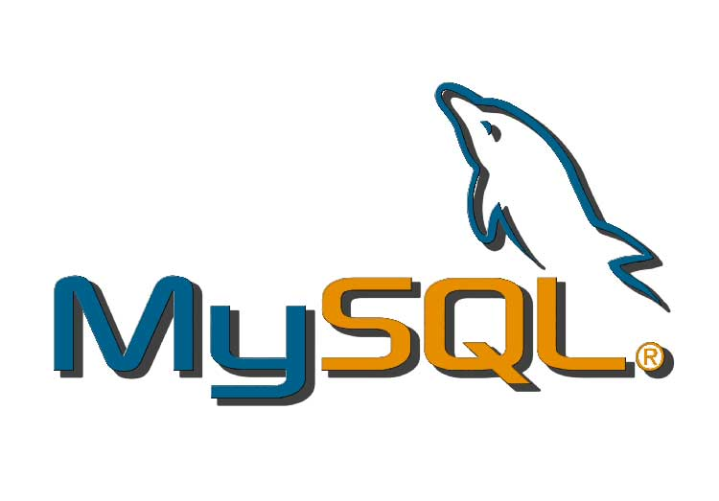

### • VISUAL STUDIO

Microsoft Visual Studio is an IDE made by Microsoft and used for different types of software development such as computer programs, websites, web apps, web services, and mobile apps. It contains completion tools, compilers, and other features to facilitate the software development process.



**HARDWARE**

* Processor (CPU) with 2 gigahertz (GHz) frequency or above
* A minimum of 2 GB of RAM
* Monitor Resolution 1024 X 768 or higher
* A minimum of 20 GB of available space on the hard disk .Internet Connection Broadband (high-speed) Internet connection with a speed of 4 Mbps.
* Keyboard and a Microsoft Mouse or some other compatible pointing device.

**CHAPTER – 2**

## ARCHITECTURE DIAGRAM

### 2.1 Use Case Diagram

A **use case diagram** at its simplest is a representation of a user's interaction with the system that shows the relationship between the user and the different use cases in which the user is involved. A use case diagram can identify the different types of users of a system and the different use cases and will often be accompanied by other types of diagrams as well. The use cases are represented by either circles or ellipses.

**Actor** An Actor models a type of role played by an entity that interacts with the subject (e.g., by exchanging signals and data), but which is external to the subject (i.e., in the sense that an instance of an actor is not a part of the instance of its corresponding subject). Actors may represent roles played by human users, external hardware, or other subjects. Note that an actor does not necessarily represent a specific physical entity but merely a particular facet (i.e., "role") of some entity that is relevant to the specification of its associated use cases. Thus, a single physical instance may play the role of several different actors and, conversely, a given actor may be played by multiple different instances.

**Association** An association specifies a semantic relationship that can occur

between typed instances. It has at least two ends represented by properties, each of which is connected to the type of the end. More than one end of the association may have the same type.

**System** If a subject (or system boundary) is displayed, the use case ellipse is visually located inside the system boundary rectangle. Note that this does not necessarily mean that the subject classifier owns the contained use cases, but merely that the use case applies to that classified.

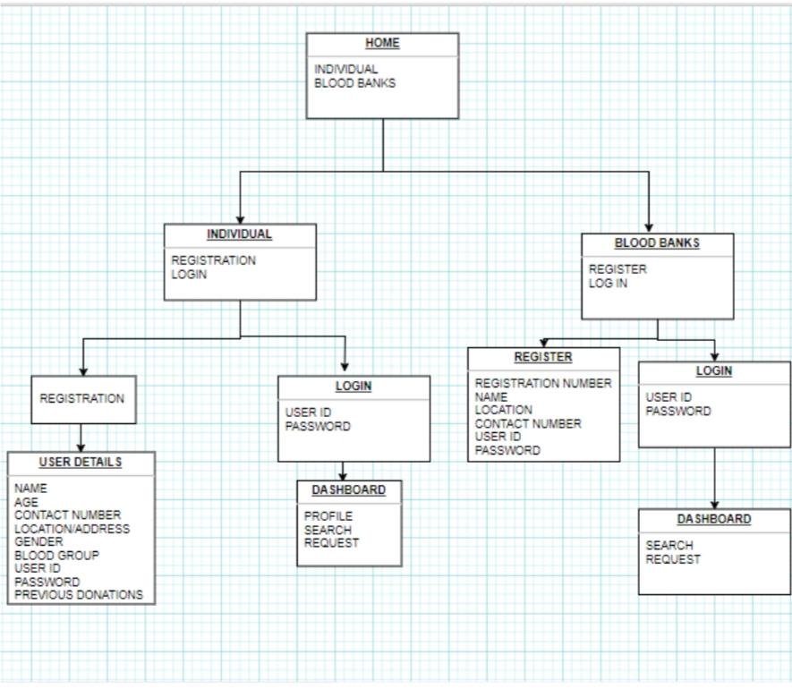

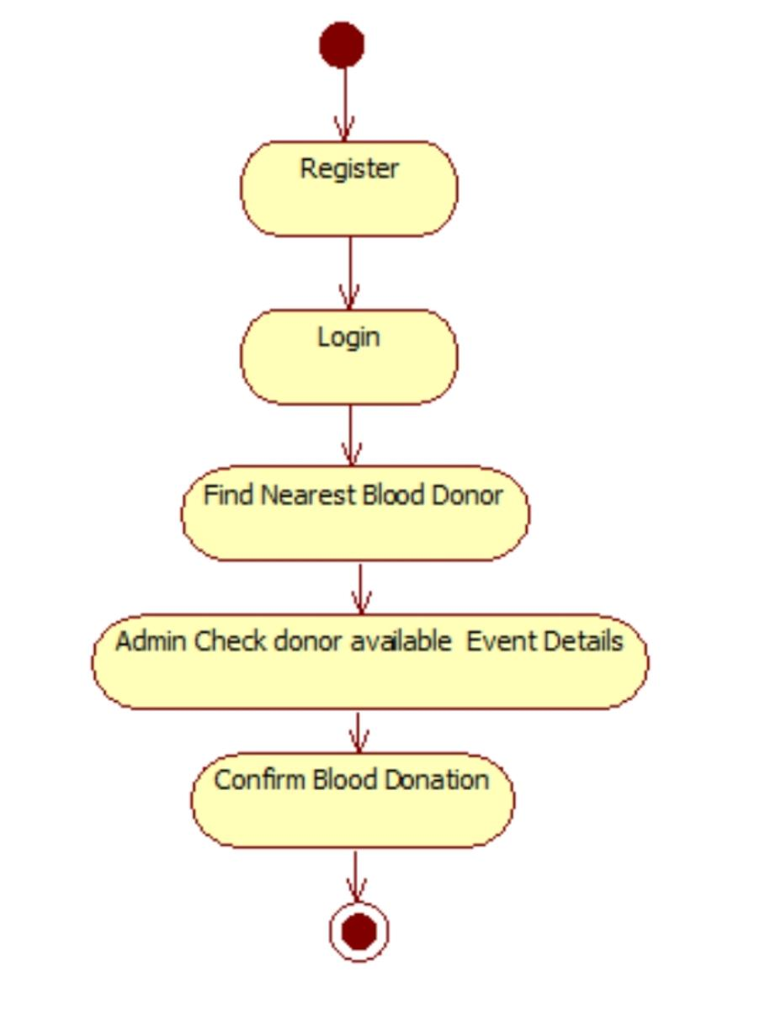

### 2.2 Sequence Diagram-

The Sequence Diagram models the collaboration of objects based on a time sequence. It shows how the objects interact with others in a particular scenario of a use case. With the advanced visual modeling capability, you can create complex sequence diagram in few clicks. Besides, Visual Paradigm can generate sequence diagram from the flow of events which you have defined in the use case description.

## Actor

An Actor models a type of role played by an entity that interacts with the subject (e.g., by exchanging signals and data), but which is external to the subject (i.e., in the sense that an instance of an actor is not a part of the instance of its corresponding subject). Actors may represent roles played by human users, external hardware, or other subjects. Note that an actor does not necessarily represent a specific physical entity but merely a particular facet (i.e., "role") of some entity that is relevant to the specification of its associated use cases. Thus, a single physical instance may play the role of several different actors and, conversely, a given actor may be played by multiple different instances. Since an actor is external to the subject, it is typically defined in the same classifier or package that incorporates the subject classifier

## Call Message

A message defines a particular communication between Lifelines of an Interaction.

Call message is a kind of message that represents an invocation of operation of target lifeline

### Sequence Diagram-

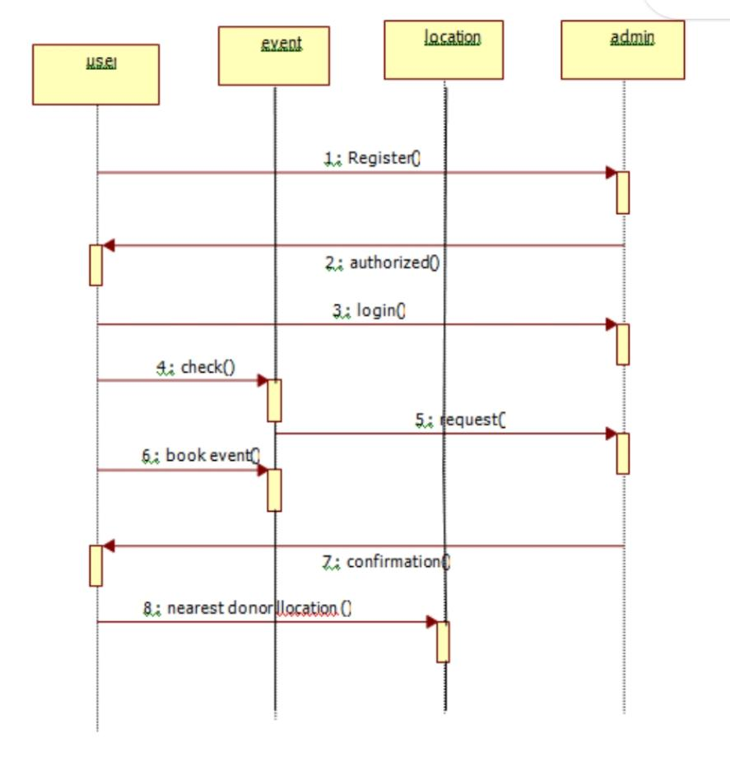

**CHAPTER 3**

### SRS (SOFTWARE REQUIREMENT SPECIFICATION)

A software requirements specification (SRS document) describes how a software system should be developed. Simply put, an SRS provides everyone involved with a roadmap for that project.It offers high-grade definitions for the functional and non-functional specifications of the software, and can also include use cases that illustrate how a user would interact with the system upon completion. An SRS should have enough information for developers to complete the software described. It not only lays out the description of the software under development but also the purpose it will serve: what the software is supposed to do and how it should perform.

#### 3.1. Scope Of Project

This project is designed for social cause to help people in their hard time. These website is created to be used by any NGO or by Government .The project Blood Donation Management System is a project that is designed For the blood bank to gather blood from various sources and distribute it to The needy people who have high requirements for it.The software is designed to handle the daily transactions of the blood bank And search the details when required. It also helps to register the details of donors.

* Track and maintain all the Donor Types-Voluntary.
* Accurate database/Record Management.
* . Donor Database-Blood Group wise and Area wise.
* . Digital Record archival backup and restoring facility-Better
* Housekeeping and Record Maintenance.
* Comprehensive Donor database with Search Facility

#### 3.2. Overall Description

Created a “WE CARE” website displaying basic information about blood donation and with security patient data of various hospital of Delhi including donor Id ,Name , Age , Gender, DOB, any disease etc.

##### 3.2.1. Technology to be used

**3.2.1.1. JAVA**

**Java** is a [general-purpose](https://en.wikipedia.org/wiki/General-purpose_language)programming languag[e](https://en.wikipedia.org/wiki/Programming_language) that is [class-based,](https://en.wikipedia.org/wiki/Class-based_programming) [object-oriented,](https://en.wikipedia.org/wiki/Object-oriented_programming) and designed to have as few implementation [dependencies](https://en.wikipedia.org/wiki/Dependency_(computer_science)) as possible. It is intended to let [application developers](https://en.wikipedia.org/wiki/Application_developer) *write once, run anywhere* (WORA), meaning that [compiled](https://en.wikipedia.org/wiki/Compiler) Java code can run on all platforms that support Java without the need for recompilation. Java applications are typically compiled to [bytecode](https://en.wikipedia.org/wiki/Java_bytecode) that can run on any [Java virtual machine](https://en.wikipedia.org/wiki/Java_virtual_machine) (JVM) regardless of the underlying [computer architecture.](https://en.wikipedia.org/wiki/Computer_architecture) The [syntax](https://en.wikipedia.org/wiki/Syntax_(programming_languages)) of [Java](https://en.wikipedia.org/wiki/Java_(software_platform)) is similar to [C](https://en.wikipedia.org/wiki/C_(programming_language)) and [C++,](https://en.wikipedia.org/wiki/C%2B%2B) but it has fewer [low-level](https://en.wikipedia.org/wiki/Low-level_programming_language) facilities than either of them.

**3.2.1.2. MYSQL**

MySQL is an open-source relational database management system. Its name is a combination of "My", the name of co-founder Michael Widenius's daughter, and "SQL", the abbreviation for Structured Query Language.

MySQL is [free and open-source software](https://en.wikipedia.org/wiki/Free_and_open-source_software) under the terms of the [GNU General Public License,](https://en.wikipedia.org/wiki/GNU_General_Public_License) and is also available under a variety of [proprietary](https://en.wikipedia.org/wiki/Proprietary_software) licenses. MySQL was owned and sponsored by the [Swedish](https://en.wikipedia.org/wiki/Sweden) company [MySQL AB,](https://en.wikipedia.org/wiki/MySQL_AB) which was bought by [Sun Microsystems](https://en.wikipedia.org/wiki/Sun_Microsystems)

This project will run on local server host and a touchscreen which will be connected to each other. python language will be used to design and implement a user interface. On the database side, MySQL will be used to design and implement the necessary entities, tables and relations.

### CHAPTER 4

#### 4.1 ER DIAGRAM

ER Model is represented by means of an ER diagram. Any object, for example, entities, attributes of an entity, relationship sets, and attributes of relationship sets, can be represented with the help of an ER diagram.

### Entity

Entities are represented by means of rectangles. Rectangles are named with the entity set they represent.

### Attributes

Attributes are the properties of entities. Attributes are represented by means of ellipses. Every ellipse represents one attribute and is directly connected to its entity (rectangle).

If the attributes are **composite**, they are further divided in a tree like structure. Every node is then connected to its attribute. That is, composite attributes are represented by ellipses that are connected with an ellipse.

**Multivalued** attributes are depicted by double ellipse.

**Derived** attributes are depicted by dashed ellipse.

## Relationship

Relationships are represented by diamond-shaped box. Name of the relationship is written inside the diamond-box. All the entities (rectangles) participating in a relationship, are connected to it by a line.

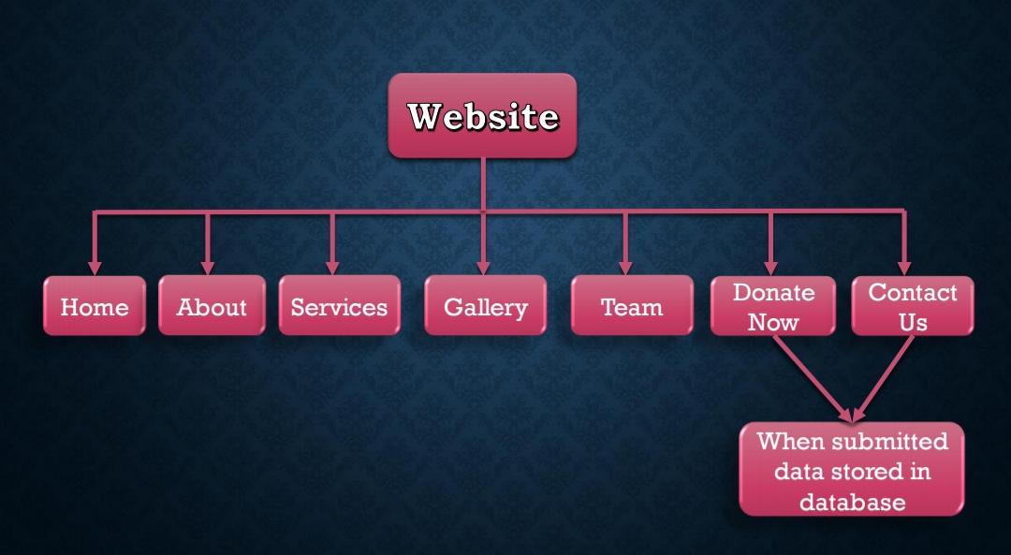 **Diagram** (DFD) is a way of representing a flow of a data of a process or a system (usually an information system). The DFD also provides information about the outputs and inputs of each entity and the process itself. A data-flow diagram has no control flow, there are no decision rules and no loops. Specific operations based on the data can be represented by a flowchart.

There are several notations for displaying data-flow diagrams. The notation presented above was described in 1979 by Tom DeMarco as part of Structured Analysis.

For each data flow, at least one of the endpoints (source and / or destination) must exist in a process. The refined representation of a process can be done in another data-flow diagram, which subdivides this process into sub-processes.

The data-flow diagram is part of the structured-analysis modelling tools. When using UML, the activity diagram typically takes over the role of the data-flow diagram. A special form of dataflow plan is a site-oriented data-flow plan.

Data-flow diagrams can be regarded as inverted Petri nets, because places in such networks correspond to the semantics of data memories. Analogously, the semantics of transitions from Petri nets and data flows and functions from data-flow diagrams should be considered equivalent.

Attributes

Entity

### Zero Level Dfd-

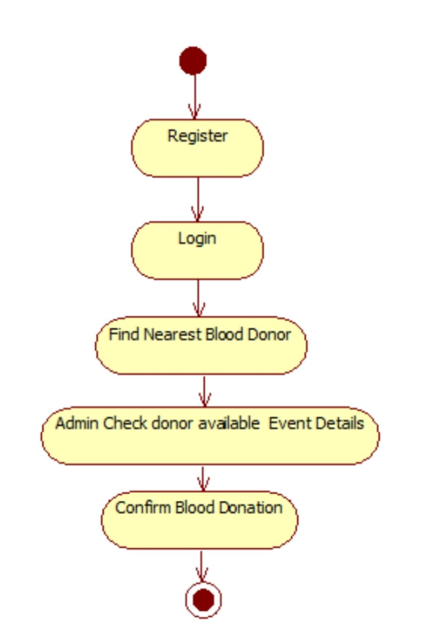

***DFD:***

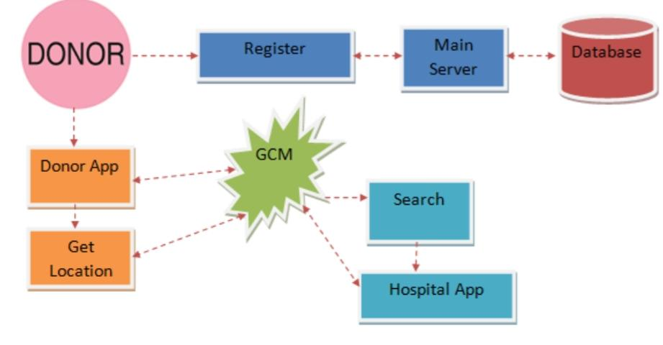

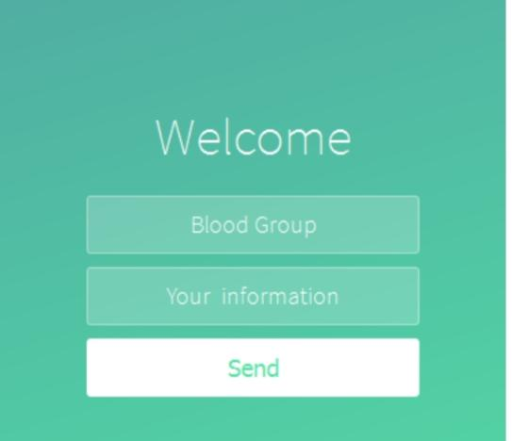

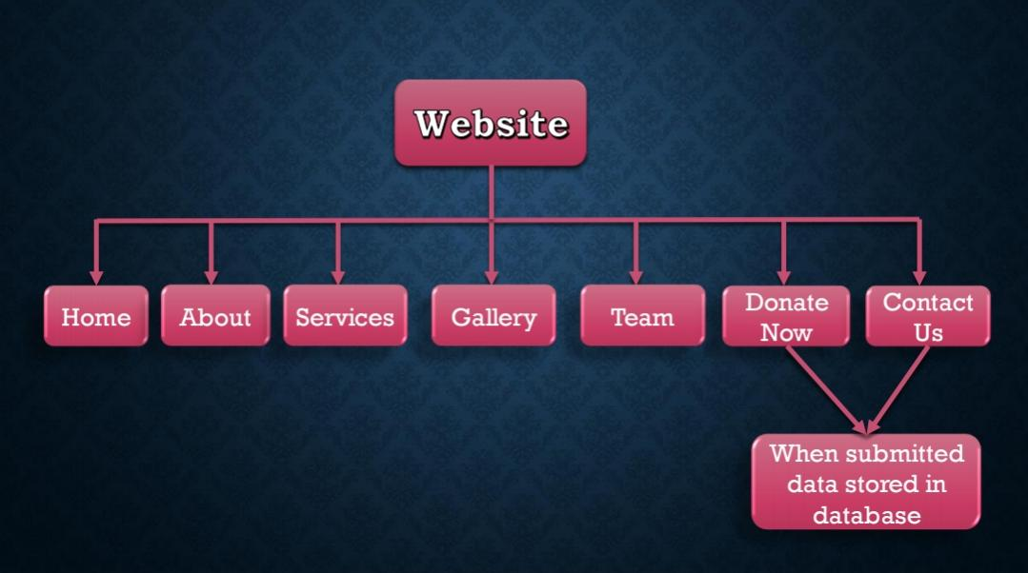

**CHAPTER 5**

### MATERIAL AND METHODOLOGY

Several materials are used to built this project . Certain software interfaces are used like window 8/10 , 4gb ram/ 255gb hdd .Technologies are also used like JAVA, MY SQL, PHP, for full stack development tools.

1. First of all, user visit the homepage
2. User can navigate through the navigation tab to access various other features
3. The user can see the data of hospitals of his city and then compare them after submitting his details.

### 5.1 PROJECT DESIGN

This describes the proposed system, explaining how modules and components integrate and Communicate to bring about the working application of the proposed system. The website

design is developed to satisfy the requirement of modern system architecture including computational structures andmodel training algorithms. The website design will also capture the major functional building blocks needed to understand the process of building a system.

#### 1. Users 2. Admin 3. Guest

##### • Guest Users

Guest user can view the website and check out the information about covid.

##### After successful login user can do the following things–

The user can see the data of hospitals of his city and can compare them on the basis of recovery rate , symptoms expenditure and various other factors as well.

##### Admin

Admin is the superuser of the website who can manage everything on the website. Admin can log in through the login page

##### Admin Features–

Admin can access the user details and can add more hospitals for more Scalability and can add more info of patients in particular hospital.

### MODEL APPROACH

#### INTERFACE REQUIREMENTS

SOFTWARE INTERFACE • Windows 8/10.

* 4 gb ram / 256gb hdd
* MySQL
* Html
* Javascript & PHP

Several materials are used to built this project . Certain software interfaces are used like window 8/10 , 4gb ram/ 255gb hdd , MySQL . Technologies are also used like Javascript for development of the project. MySQL is used for free open source database to store the data .

#### CHAPTER 6 RESULTS AND SNAPSHOTS

##### 6.1 Result

Therefore, after implementing all the mentioned libraries as well as software tools, we finally full-fledge website .

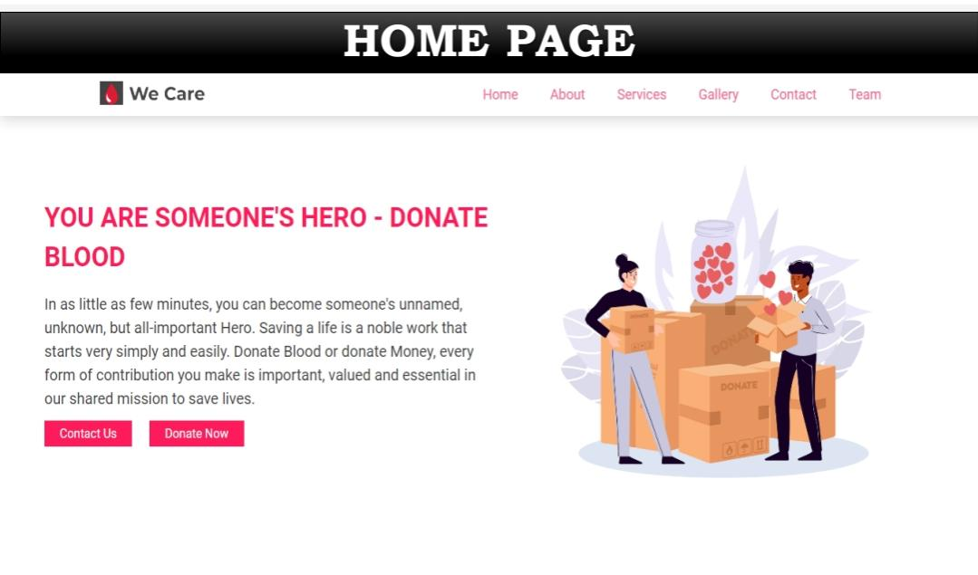

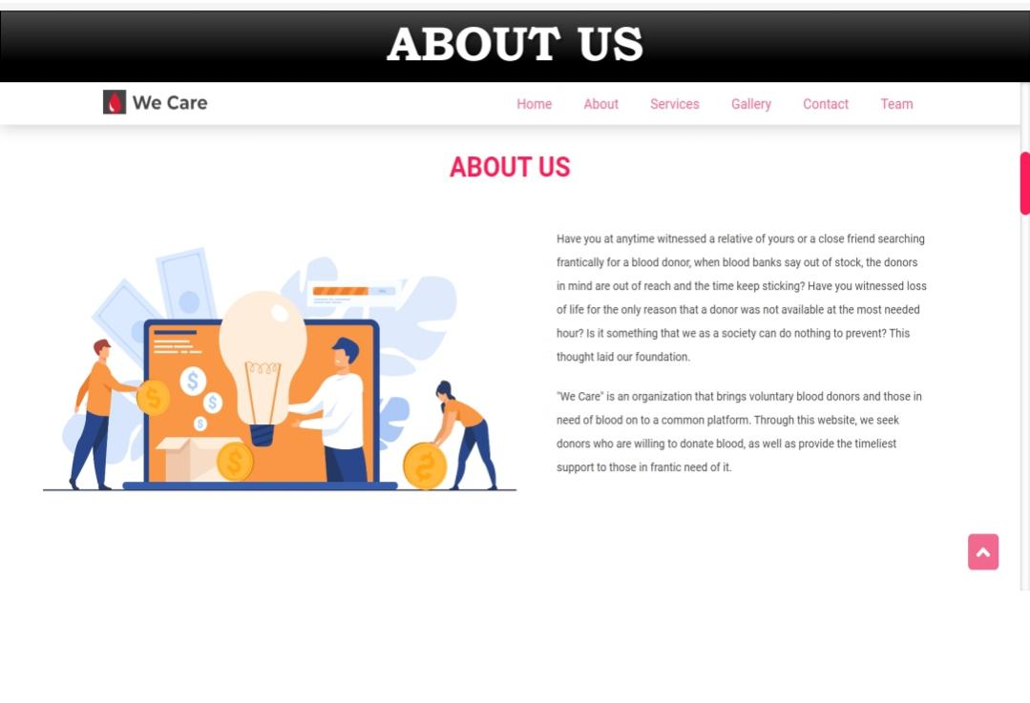

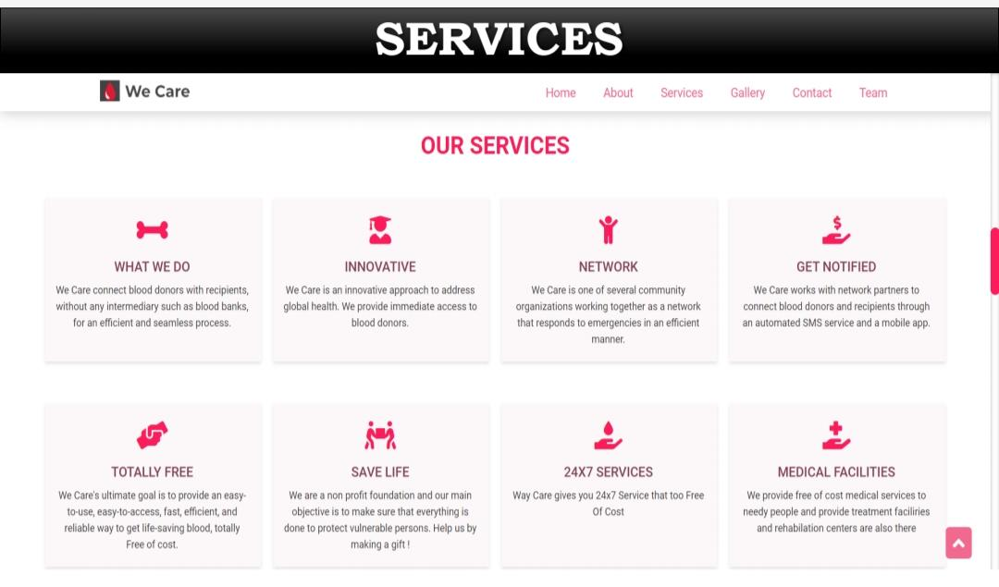

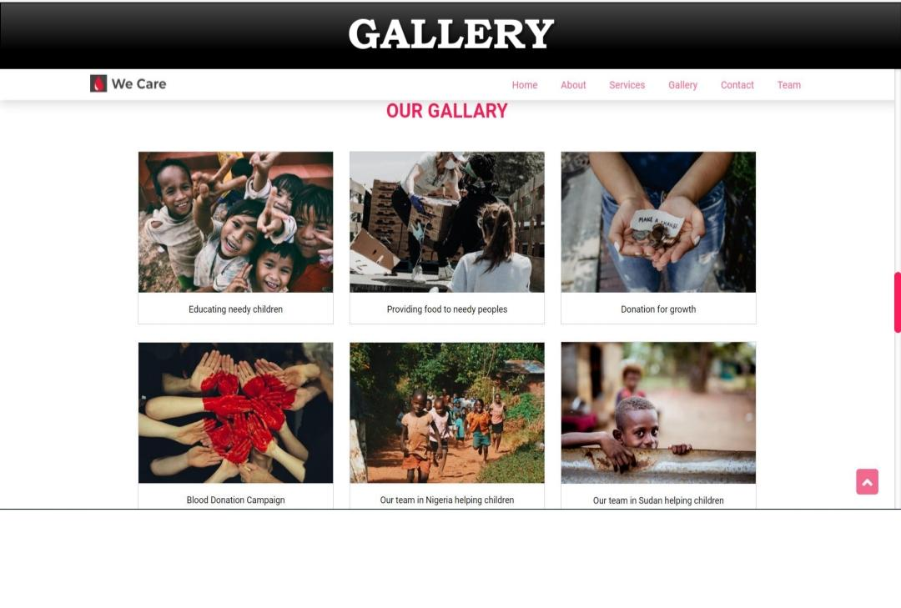

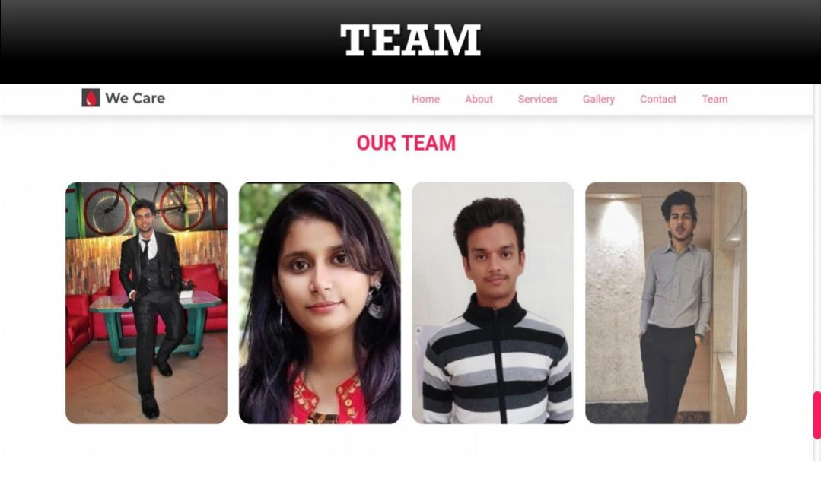

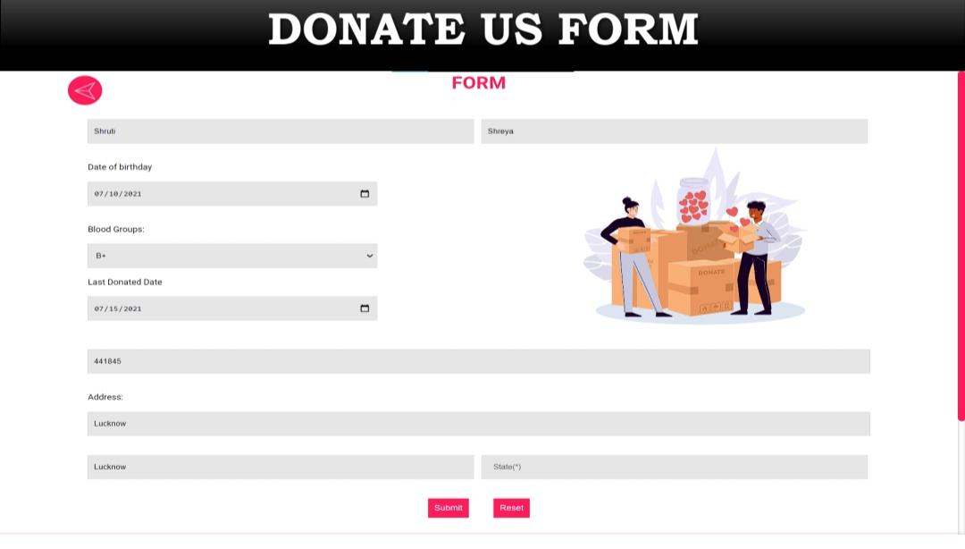

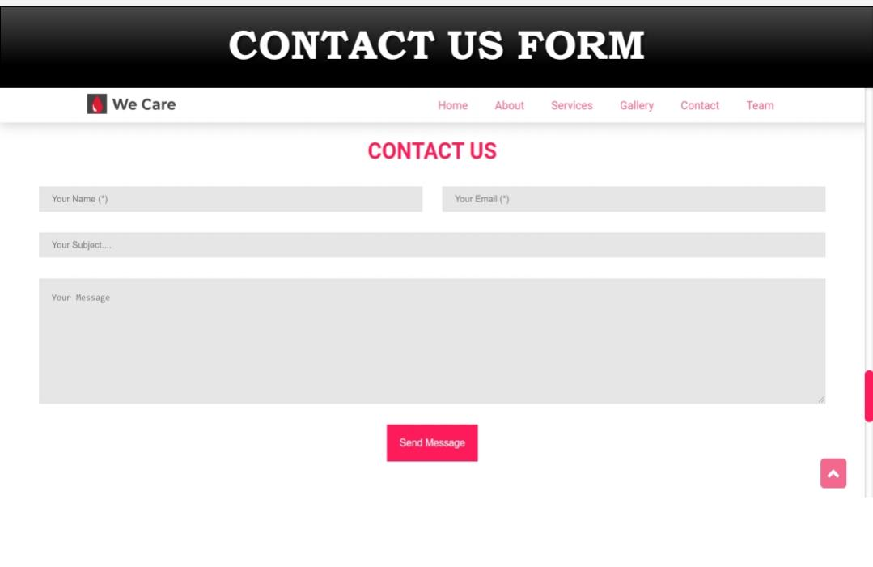

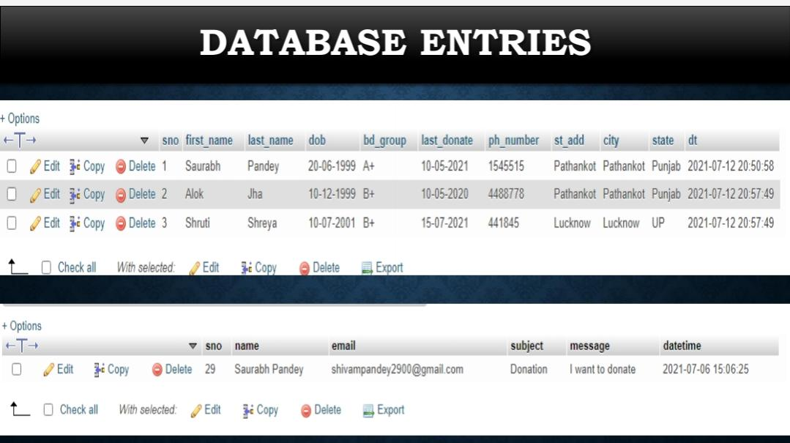

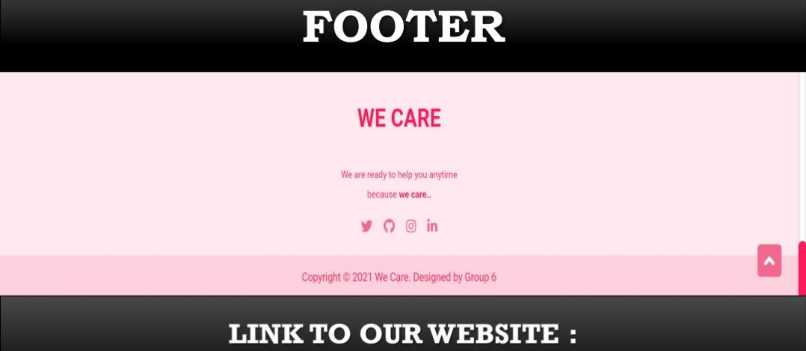

https://reddevill007.github.io/Blood-Donation-Website/

**Chapter 7**

#### CONCLUSION AND FUTURE SCOPE

Our project is only a humble venture to satisfy the needs to manage their project work. Several user friendly coding has also been adopted. The objective of the software planning is to provide a framework with a limited project completion time frame at the beginning of the project and should be updated on a regular basis.

### POSSIBLE FUTURE WORK

* System can be expanded with availability over worldwide.
* Reaching as close as possible of the donor from emergency zone.
* A smart phone application of the system can be made.
* Providing Donors an option of change his/her availability.
* Generating reports on Stocks-Blood Group wise, Area wise and Eligibility

Wise.

Thank you